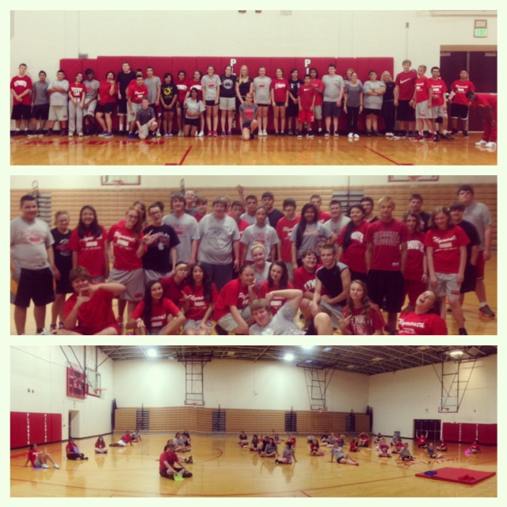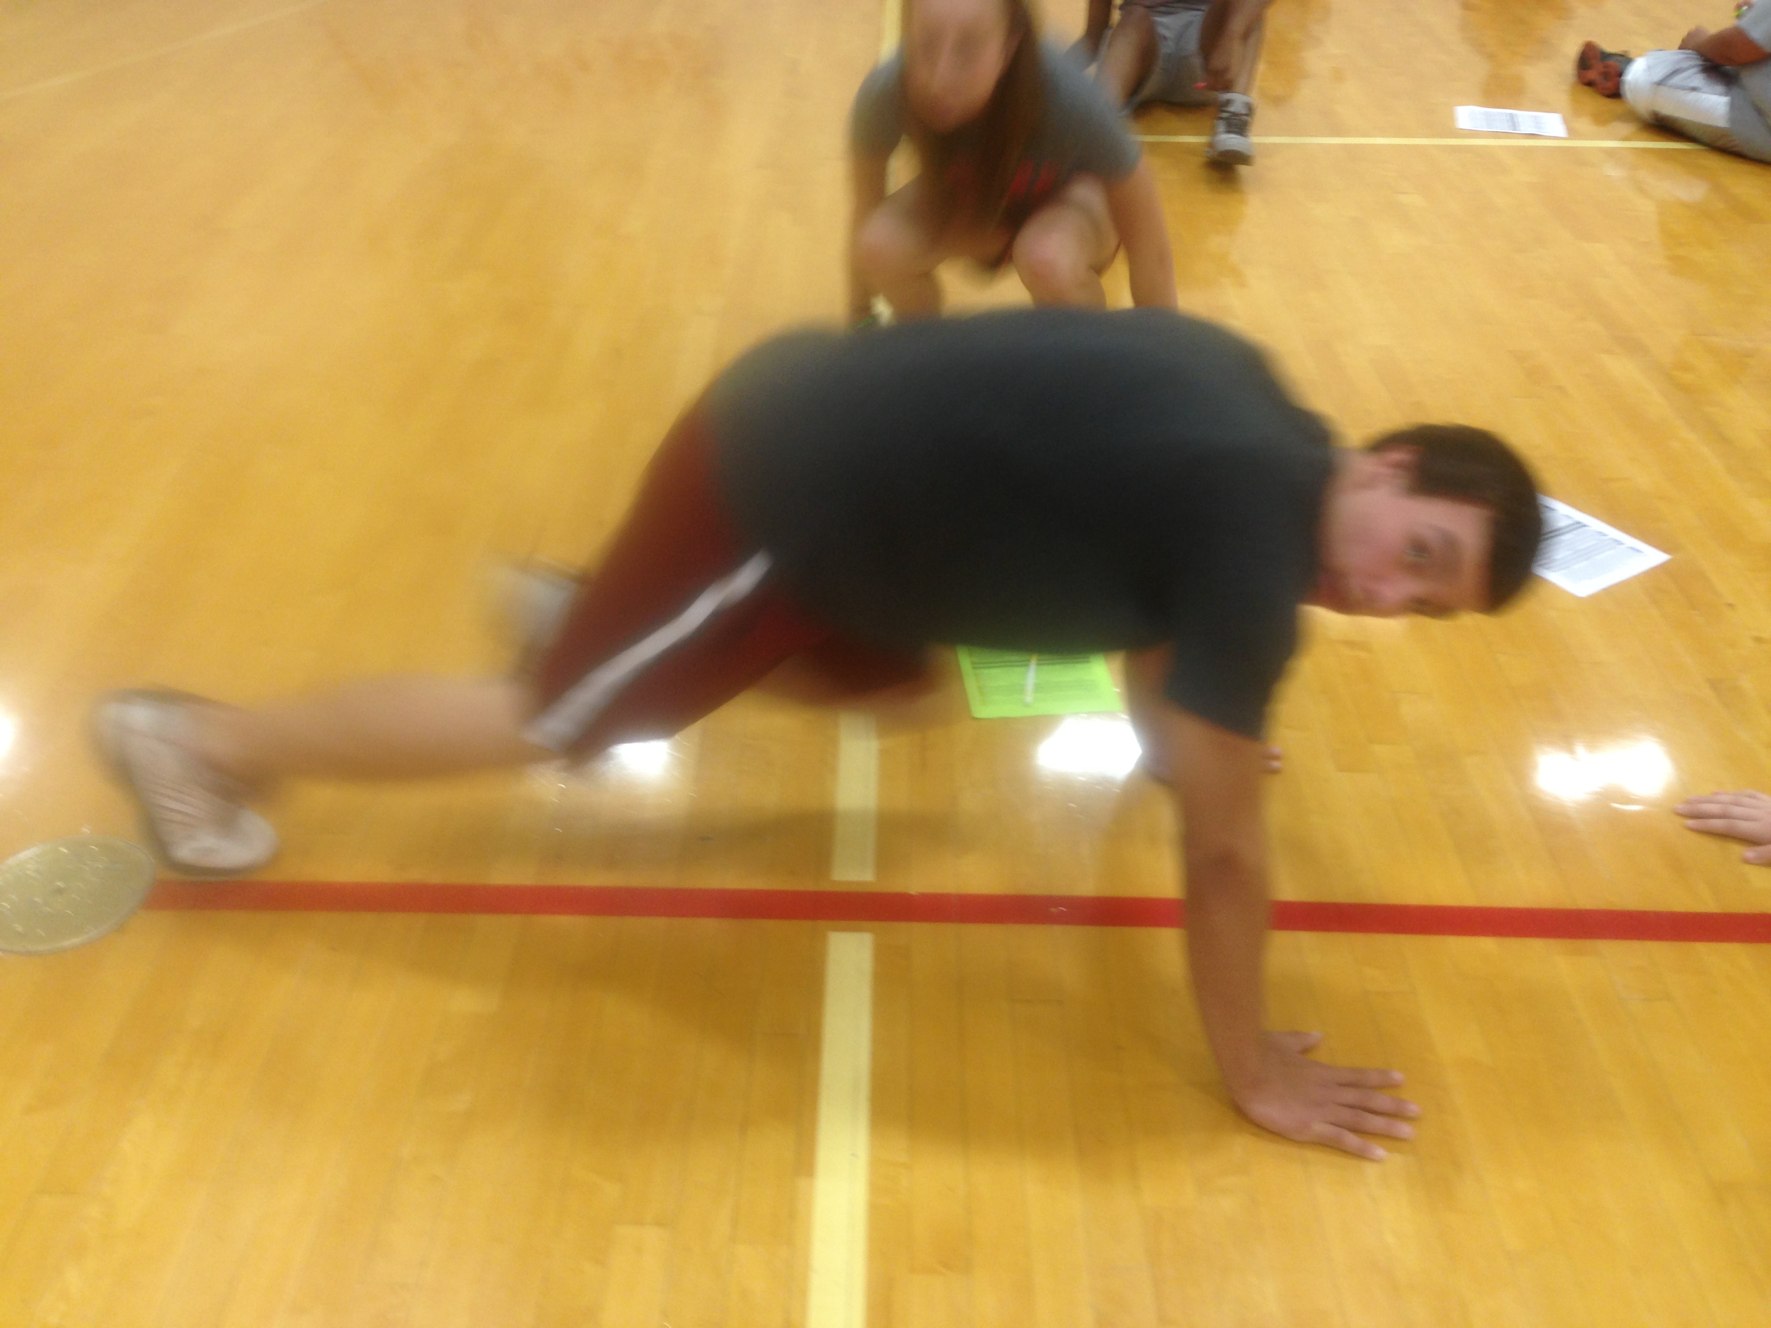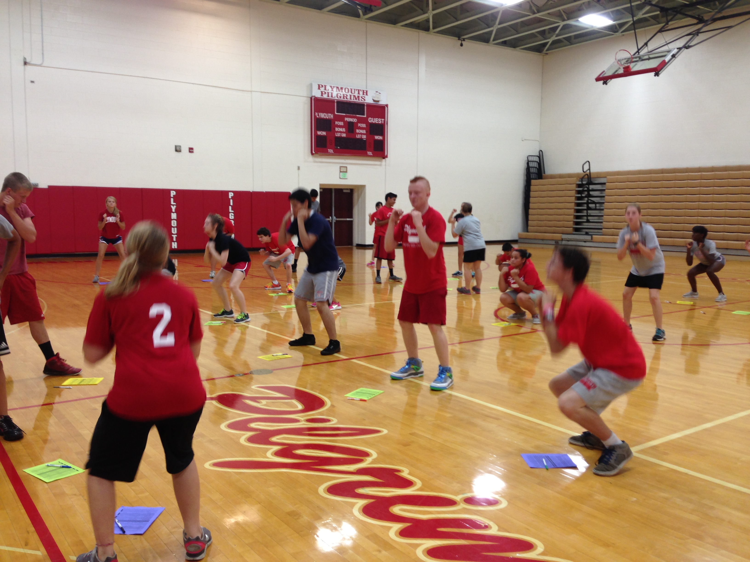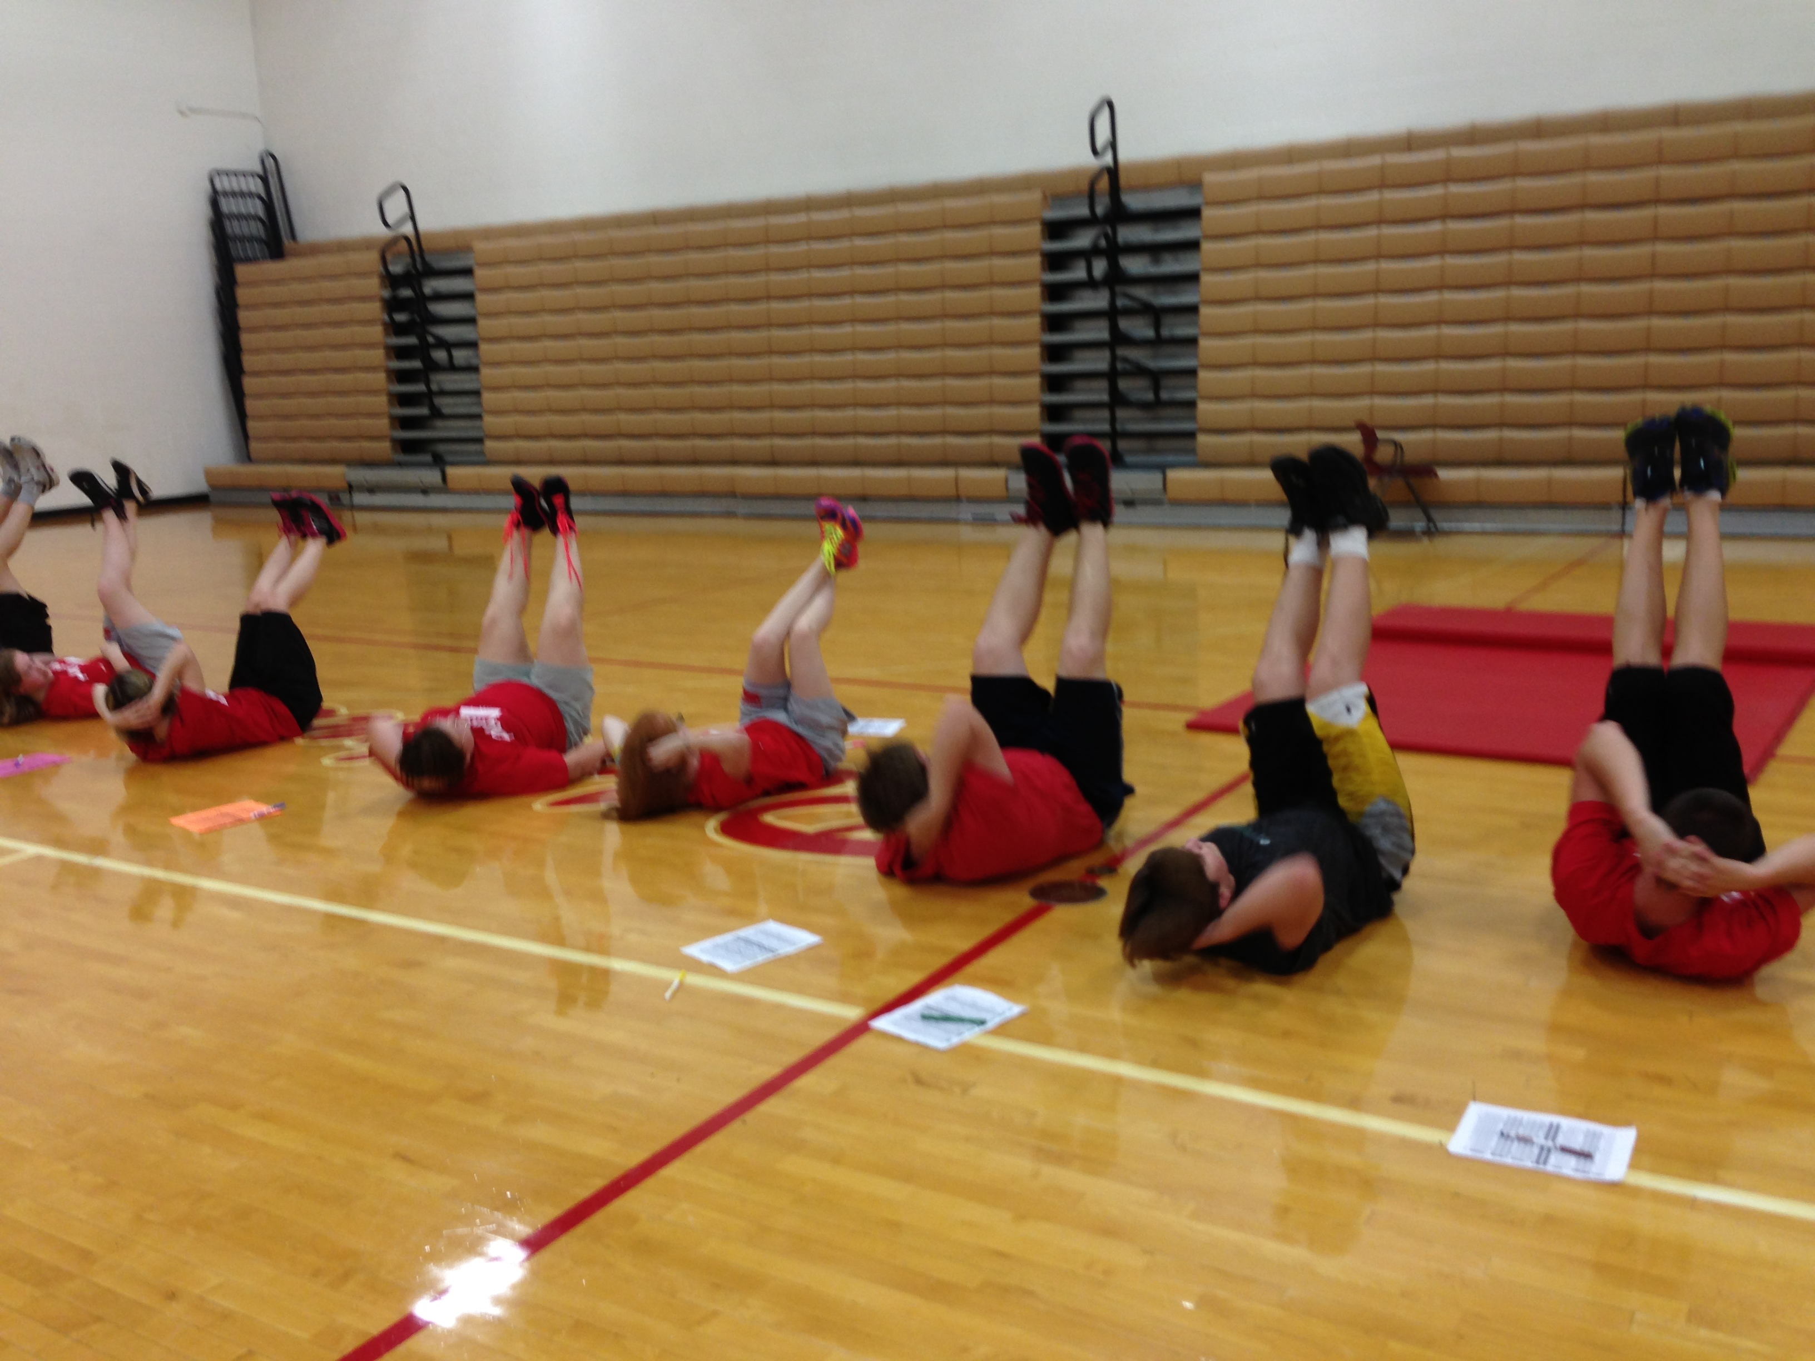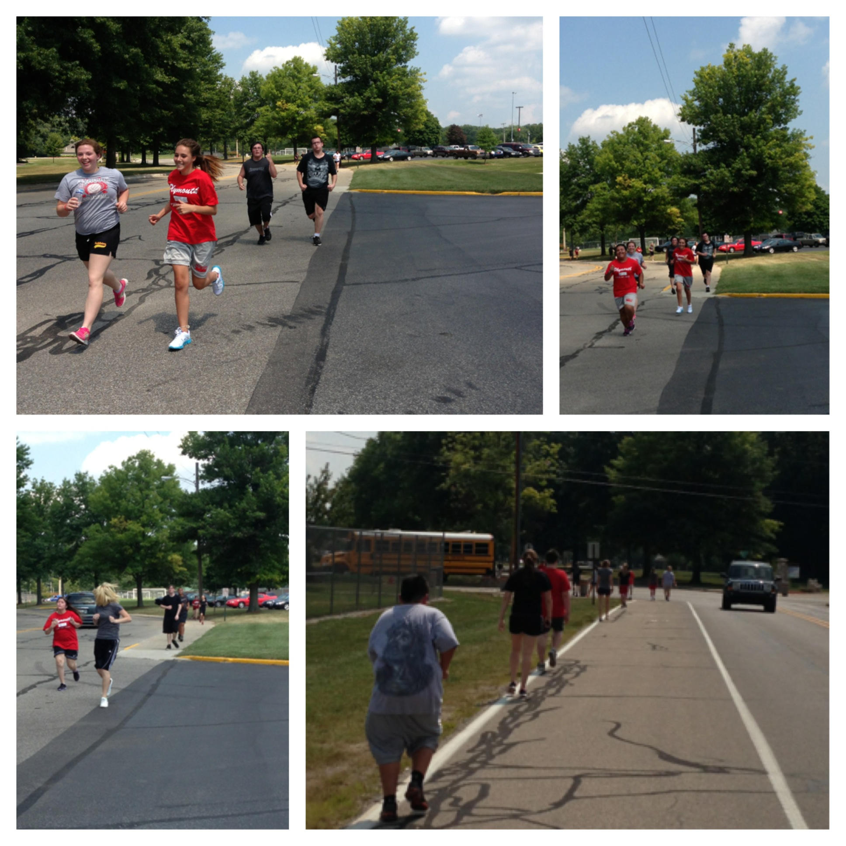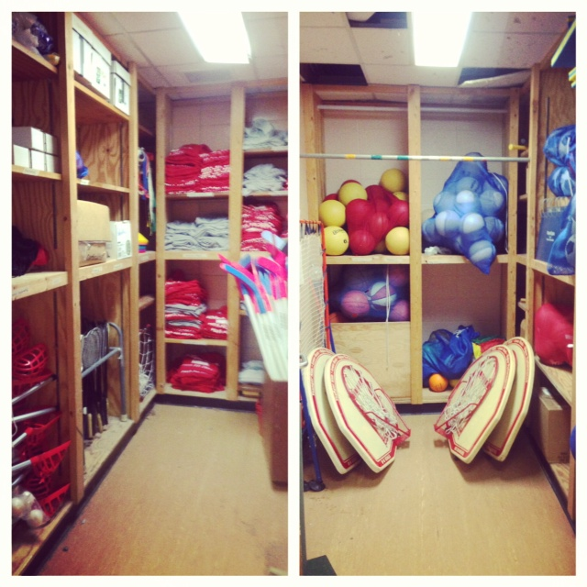

Pilgrim Pride Gatorball Scoop

**Pg.1**

**Great Job!**

Plymouth High School students exemplify what it means to be dressed to impress. The newly implemented dress code for physical education requires each individual to dawn the colors red, black or gray. The pride that each student took on the first day of class was quite “impressive.” **Over 97% of the students (160 enrolled) wore a complete uniform on day 1. It continued to improve as the week went on! I am so proud of our students!**

## Plymouth High School Physical Education Students Dress for PE

# Dressed to Impress

Plymouth PE Newsletter Vol. 1

###### More inside!

[8-23-2013]

On Tuesday we completed our first fun run! It required students to leave the comforts of the gym walls and venture out into the beautiful fall breeze. The fun run took them from PHS to Centennial Park. The completion of this run totaled 1.25 miles.

On Friday each student completed a time mile. Four laps around the Rockies track as fast as they were able to run. It was a great success as every student completed the test

“Fall into Fitness”

To prepare each day students complete a series high intensity fitness activities. Those activities include squats, Mt. climbers, push ups, burpees, sit ups/core exercises, lunges, and cardio.

At the end of each week they will complete 2.5 miles, 100 push ups, 125 squats, 125 Mt. Climbers, 350 sit ups, 100 lunges & 15 burpees.

Preparation is Key

All physical education classes participated in the The President’s Challenge for physical fitness….. it’s for everyone. Really. Truly. All ages and all abilities are welcome to try it. All the students needed was the desire to get active (or increase their current activity level) and eat healthy. Now more than ever, we all need some incentive to make physical activity and healthy eating a part of our daily routine, and the President’s Challenge is where you’ll get it.

The Physical Fitness Test**\*** recognizes students for their level of physical fitness in five [activities](https://www.presidentschallenge.org/challenge/physical/activities/index.shtml):

* Curl-ups, Shuttle run, Endurance run (1 Mile) Pull-ups ,-sit reach

In the semi-final match the gators faced Westwood, but they posed no threat as gator chomped down on them with at 65-27 victory. In the final showdown the gators face the host team Queen Creek. The championship was ripped away from the home team as Xavier scored 52 points to the Bulldogs 32 to secure the title. Katie Werner, Ashley McGinn, Lexi Carbine and McKenna Renfro were named to the All-Tournament Team.

### PRESIDENTIAL FITNESS TEST

**WHATEVER IT TAKES!!**

A very special “Thanks” to these three PHS leaders for first, believing in our students and second, investing in them. Due to their hard work and dedication, we will have the opportunity to teach each student in a well developed, safe and properly equipped environment. Thank you for working hard for us so that we may be able to grow and work hard for our community and ourselves.

**SPOTLIGHT OF THE WEEK:**

**Superintendent- Mr. Dan Tyree**

**PHS Principal- Mr. James Condon**

**PHS: PE Department Head: Mr. John Barron**

The photo below was taken of our newly renovated and well-supplied equipment room.

#### Welcome Aboard Coach Kalei Nance and Coach Sarah Hays

**cont.**

Praesent vitae nisl.

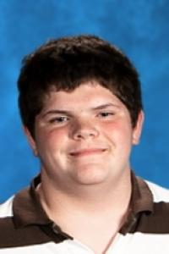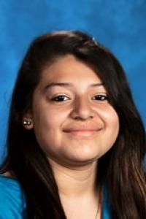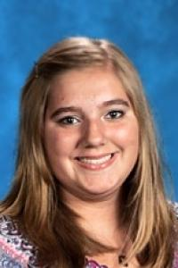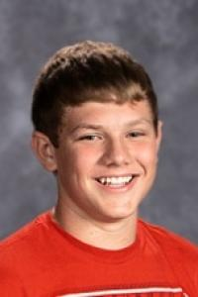

Estafania Arroyo period 4 Definitely is a force to be reckoned with in class. I think she exceeded her own expectations as she pushed through and excelled in each exercise

Jennifer Sayer period 1 is such an inspiration. Making a commitment to completing all of the required PE exercises she totaled up 2.5 miles running this week!

Daniel Vesgo period 1 Has made a great impact in his first week of PE. Running a great mile and showing up to class each day with a positive attitude.

Garrett Garver period 5 enters class everyday with a smile. I was proud to watch him tackle each fitness test this week with a positive attitude as he pushed himself and encouraged others as well.

Alivia Hartle period 5 will not allow anything to be a set back in her journey. She pushed through each of the weeks activities will a strong will and determination that allowed her succeed.

Adreana Sharp period 6 Showed up to PE feeling ill. That did not stop her from tackling the days physical challenges. As she pushed herself literally to her limits I was reminded of why I teach.

Cameron Andrews Period 6 displayed incredible sportsmanship as help flew across the finish line in the top 3, he ran lap after lap assisting other students around the track who were having difficulties finishing.

Cotey Miller period 4 was very impressive as he completed all of his fitness requirements each day along with a 100% dress percentage.

Coach Vinson’s Student Athlete of the Week